Join us for the 2nd Annual Frostbite Tour to be held on the 16th to 19th July 2024 for Veteran cars only.
This years Frostbite will be leaving from Keith and Anne Bartley’s property outside of Dalby on Tuesday the 16th and traversing through stops at Millmerran, Warwick, Oakey and returning back to Keith and Ann’s on the Friday the 19th.
More Info @ lenkelly40@gmail.com or 0418734268
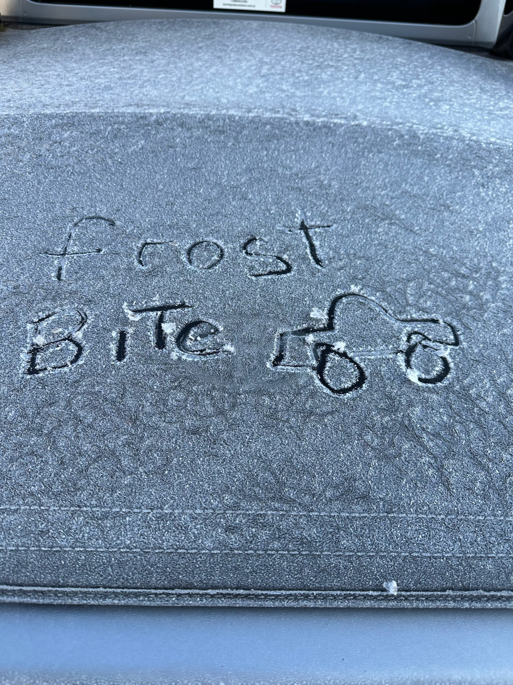

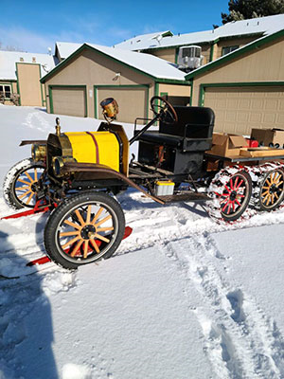
The tour will be a progressive tour covering about 520Klm over four days with regular regroups and open to all Veteran cars. Travel to Keith and Anne’s the day before or early on the 16th July and leave your car and trailer there, before setting off to and overnighting 16th July at Millmerran, 17th at Warwick and 18th at Oakey, and then returning to Keith and Anne’s on the 19th July for packing up, and then there will be a farewell lunch back in Dalby. Two backup vehicles and trailers will be following and will help to carry extra baggage etc. Another vehicle will be in front setting up for Morning Tea and Lunch each day.(Covered by Entry Fee) Accommodation, other meals and Farewell Lunch will be at entrant’s expense. Entry available In New Year.

