ENTRY FORM 2022
Please print clearly

Driver: First Name Surname
Passenger: First Name Surname
Additional Passengers’ Names:

Postal Address:
Suburb: State Postcode
Phone: Mobile:
Email Address:
Vehicle Make: Model: Year:
Registration Number: Club Name:
Emergency contact name: Mobile:
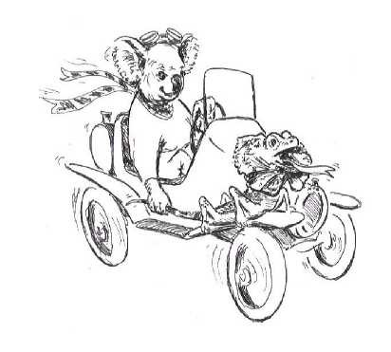

RALLY ENTRY FEE AND CALCULATION
 | Number | Cost | Total
Rally Entry (includes rally bag & name badge for the driver) | 1 | $120.00 | $120.00
Additional adult passengers |  | $60
Grand Total
NOTE: Entries after 4 April 2022 may not be accepted.
I am paying by: cheque □ or bank transfer □
If paying by cheque make payable to Veteran Car Club of Australia (NSW)Inc.
If paying by bank transfer NAME: VCCA(NSW)Inc
BSB: 062707 Account:10042491 Reference: Surname and initial
Catering information form (for your meals and functions) will be available at a later date.
DECLARATION AND INFORMATION
- The vehicle stated on this entry form, if being driven during 2022 1 & 2 National Rally, is fully registered or registered under a conditional registration scheme and fully insured.
- The VCCA(NSW)Inc, the club’s committee and 2022 National Rally Committee, club members, co-ordinators, agents and other associated clubs and organisations do not admit liability and in no way be held responsible for any loss of life, injury or damage suffered by/or to any vehicle, entrant, owner, driver or passenger, or any other persons or property through any circumstances.
- All entrants, owners, drivers and passengers’ entry and participate in this event solely at their own risk and waive any right of action at law against the incorporated club, its committee, members, coordinators, agents and associated clubs and organisations.
- Cancellation and refunds. If the entry has been accepted and payment made, but for a reason you are unable to join the rally, we will give you a full refund if you notify us by 4 April 2022. Cancellations after that date will not be eligible for a refund unless exceptional circumstances apply.
Please send this completed and along with payment on or before 7 March 2022.
Please email to Narrandera2022@gmail.com Or post to 2022 National Rally 23 Wintergreen Place WEST PENNANT HILLS NSW 2125
For general rally enquiries contact:
Robert Fordham Email: Narrandera2022@gmail.com Mobile: 0413 436 663

NAME: _______________________________________________________________

Signature: ______________________________________ Date: _________________

